**PRATIK GUPTA**

**GIT BRANCHING – JS ASSIGNMENTS**

**SECTION 03 – (1-14)**

**SECTION-3 - (JavaScript assignments) Steps to follow:**

**1. Create a new branch ‘js-assignments’.**

**2. Switch to ‘js-assignments’ branch.**

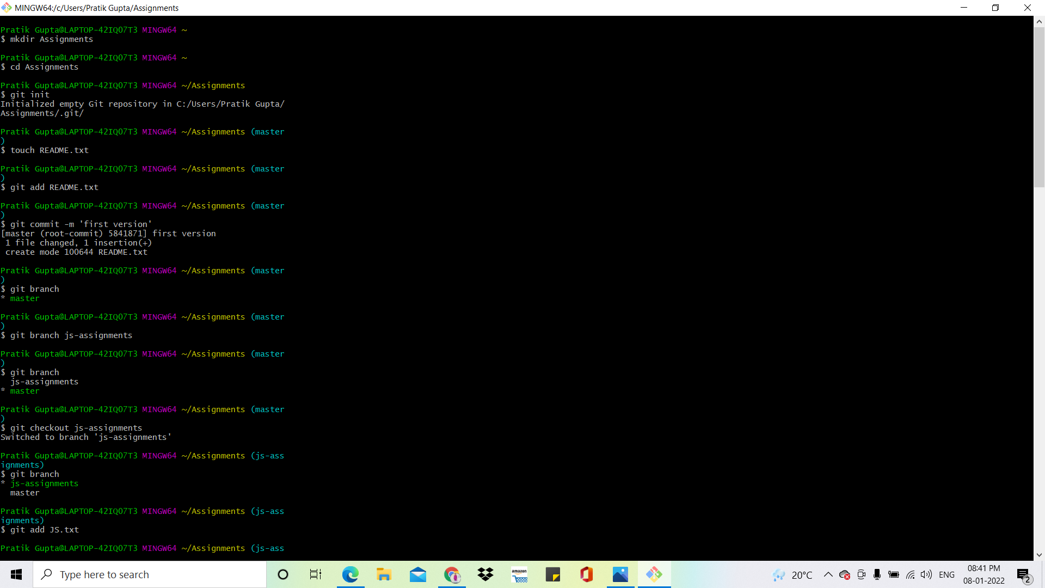

**3. Copy all JavaScript assignments inside ‘Assignments’ folder.**

**4. Commit JavaScript assignments into ‘js-assignments’ branch.**

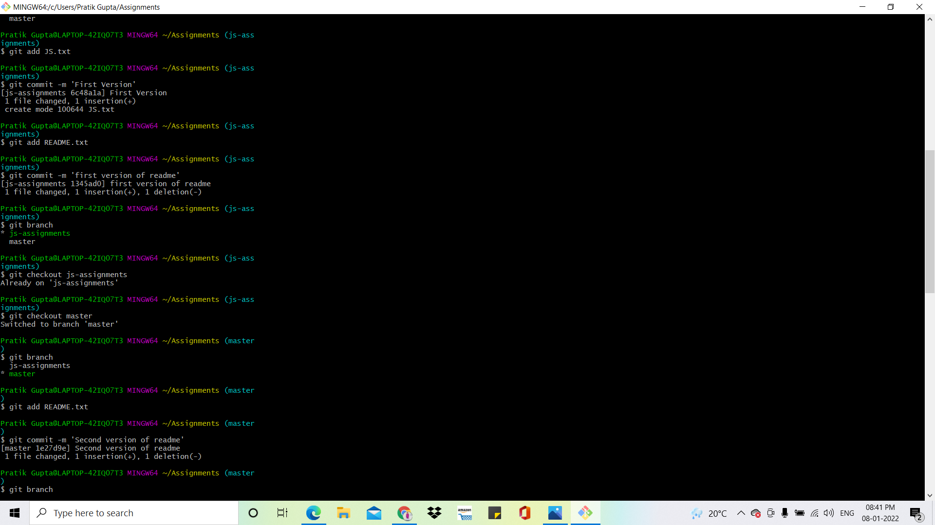

**5. Make minor changes into README.txt file on line 1 belonging to ‘js-assignments’ branch.**

**6. Commit those changed files.**



**7. Switch to master branch.**





**8. Make minor changes into README.txt file on line 1 & commit those changes into master.**



**9. Again switch to ‘js-assignments’ branch.**

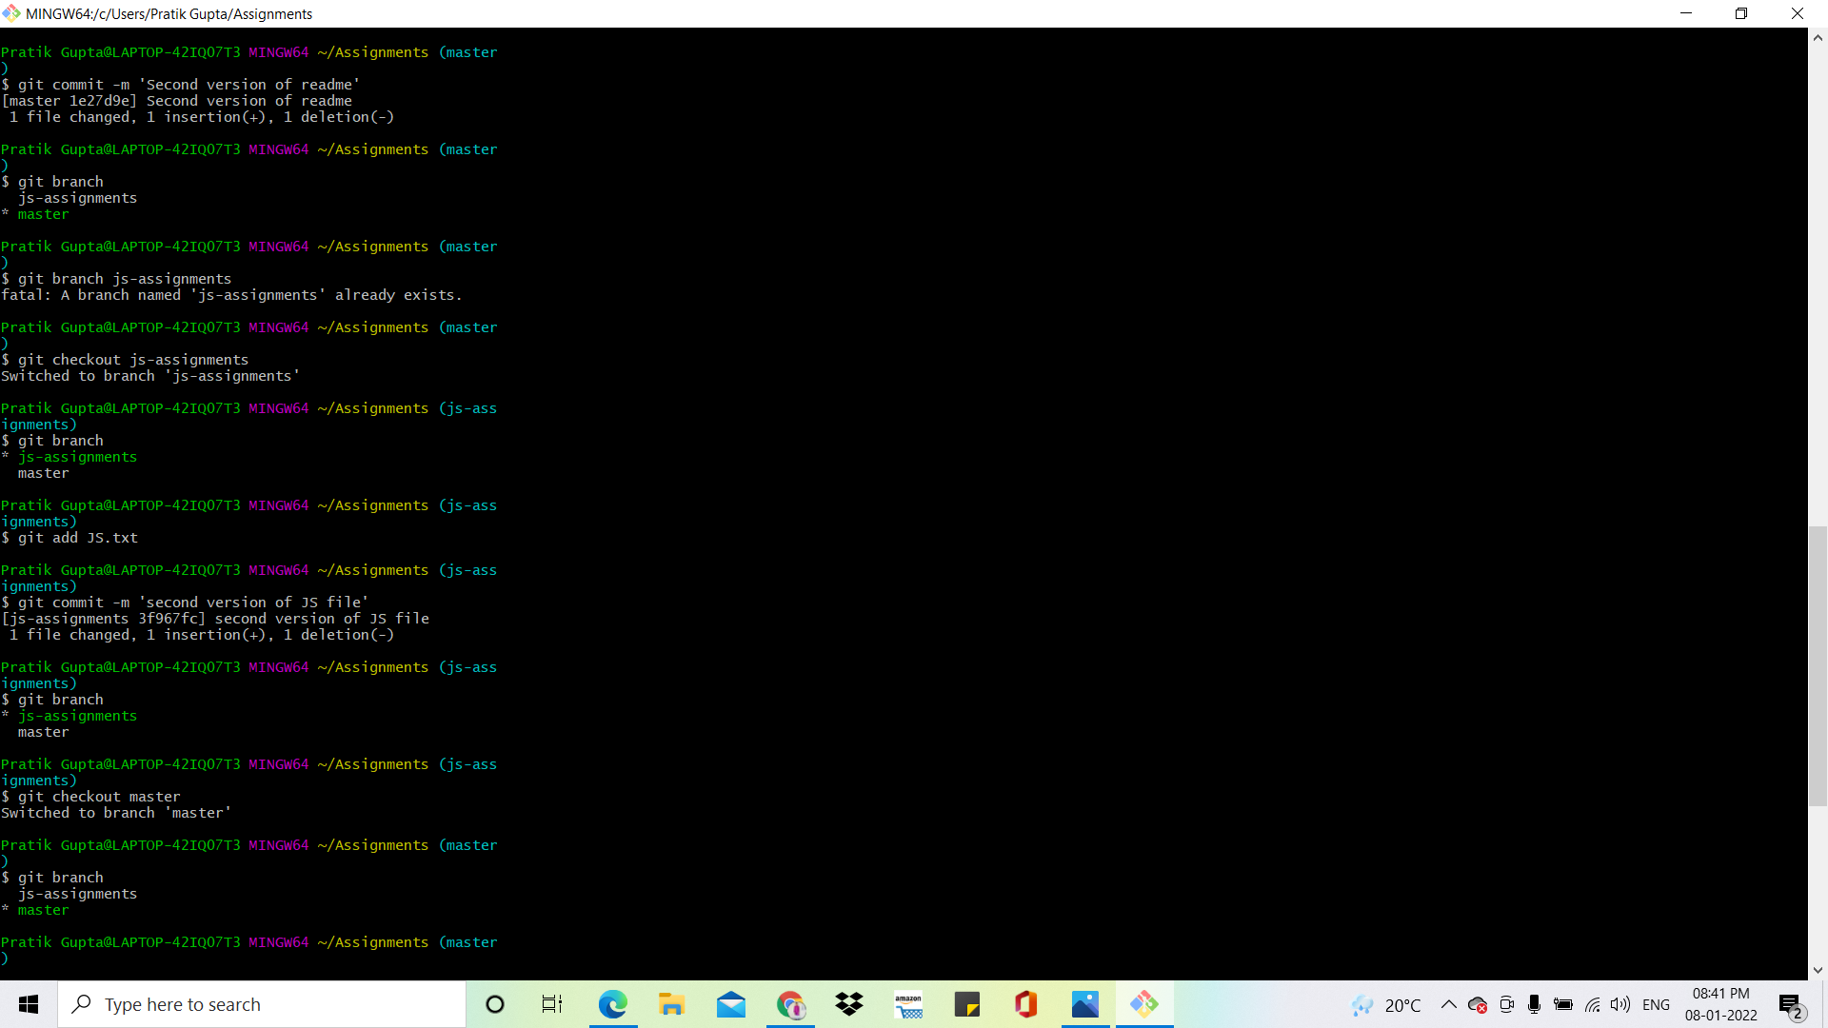



**10. Make minor changes into few files belonging to ‘js-assignments’ branch.**

**11. Commit those changes.**



**12. Switch to master.**



**13. Merge ‘js-assignments’ branch into master. Confirm all JavaScript assignments are shown in master.**

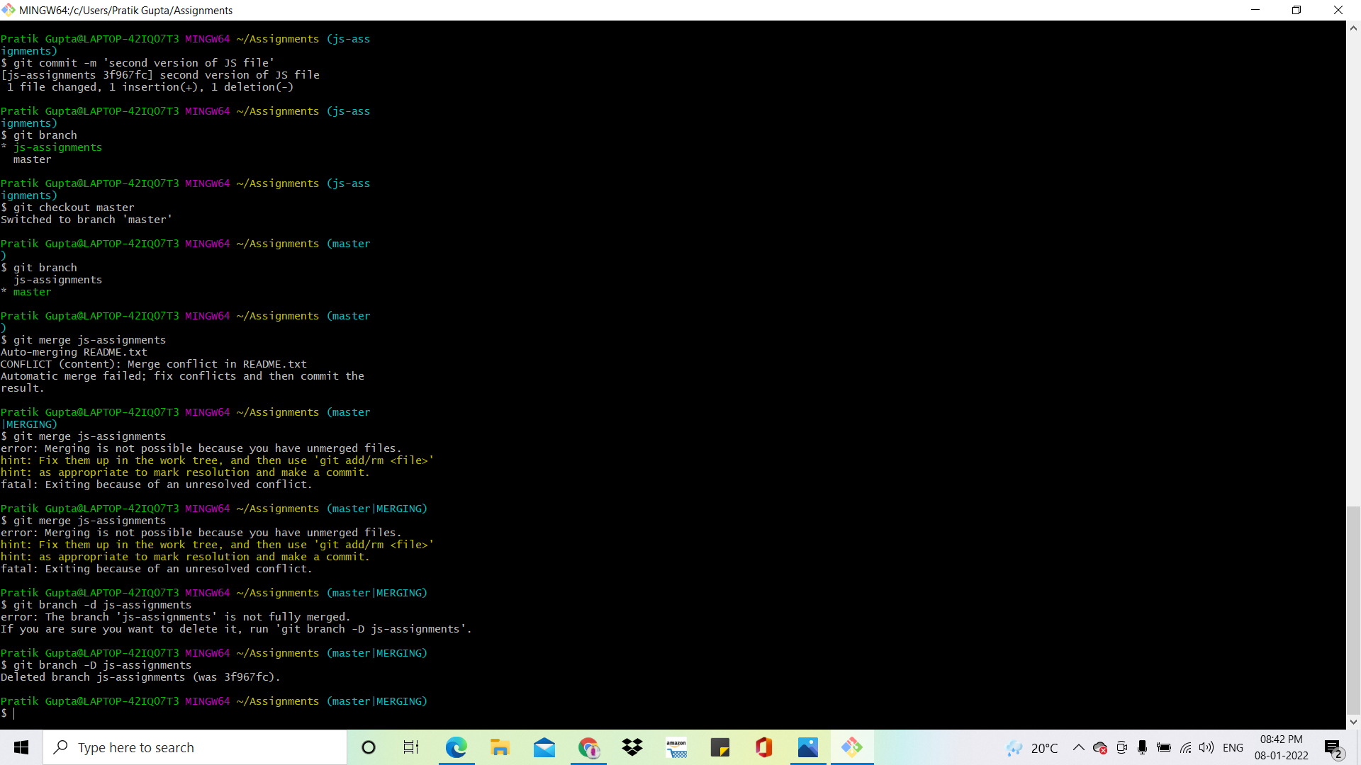

**14. Finally delete the ‘js-assignments’ branch.**

